**Left Function**

* Allows you to extract a substring from a string, starting from the left-most character.
* The first argument is a string value and the second argument is an integer value specifying the length.
* Returns the first characters of the specified length starting from the left side of the string entered as the first argument.
* If the number of characters exceeds the length of the string, the LEFT function will return string.

**LEFT (string, number_of_characters)**

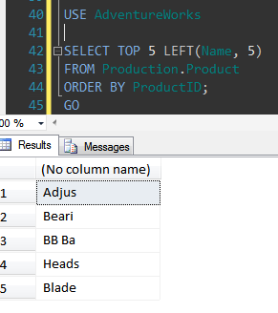

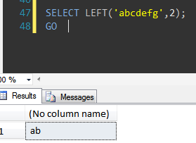

**Right Function**

* Allows you to extract a substring from a string, starting from the right-most character.
* The first argument is a string value and the second argument is an integer value specifying the length. It returns the last characters of the specified length starting from the right side of the string entered as the first argument.
* If the number of characters exceeds the length of the string, the LEFT function will return string.

**RIGHT (string, number_of_characters)**

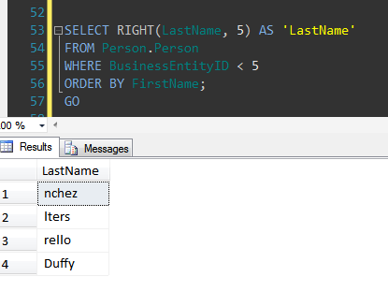

**CharIndex Function**

* Returns the location of a substring in a string. The search is NOT case-sensitive.
* Also returns an integer.
* Operates on char, nchar, varchar, nvarchar, text, and ntext data types only.
* Returns the starting position of the first occurrence of a pattern in a specified expression, or zeros if the pattern is not found.
* Start_position is optional.

**CHARINDEX (substring, string, [start_position])**

The following example returns the position at which the sequence of characters bicycle starts in the DocumentSummarycolumn of the Document table in the AdventureWorks2012 database.

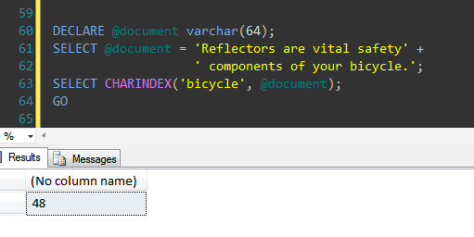

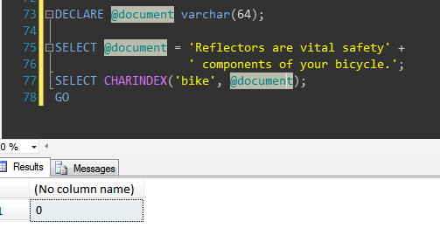

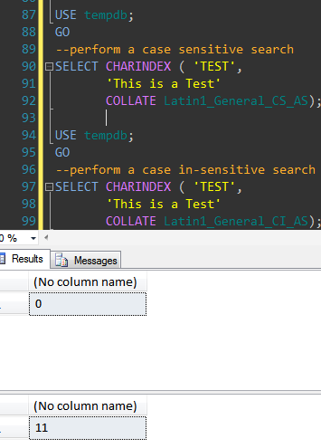

The following example uses the optional start_location parameter to start looking for vital at the fifth character of the DocumentSummary column in the AdventureWorks2012 database.

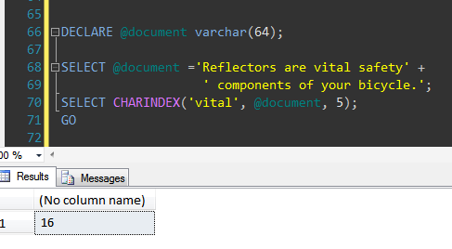

**Substring Function**

* Used to get part of string from specified string.
* Returns part of a character, binary, text, or image expression in SQL Server.
* The first position in string is 1.
* If length is a negative number, then the SUBSTRING function will return an error.

**SUBSTRING (string, start_position, length)**

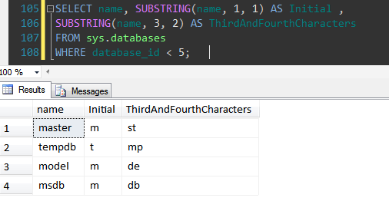

**Replicate Function**

* Returns a string value a specified number of times.
* Returns the same type as string expression.
* This function is mainly used in situations when user needs to make sure that all data in given column should be of fixed length

**REPLICATE (string_expression, integer_expression)**

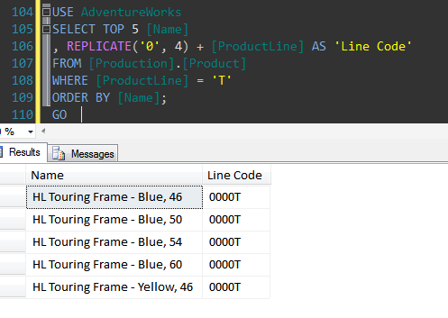

**Space Function**

* Returns a string with a specified number of spaces.
* RTRIM() function removes any trailing blanks  from a string or column. And LTRIM() removes blanks from the beginning of a string instead of end.

**SPACE (number)**

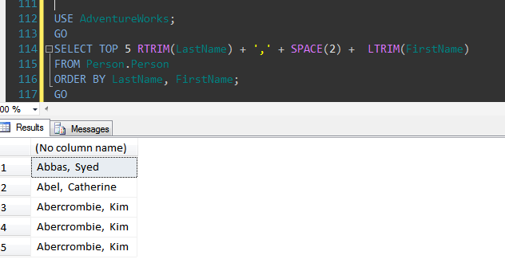

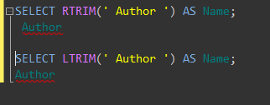

**Patindex Function**

* Returns the location of a pattern in a string.
* The search is not case-sensitive.
* The first position in string is 1.
* If the pattern is not found in string, the PATINDEX function will return 0.
* Patindex can use wildcard characters.
* The Patindex function operates on char, nchar, varchar, nvarchar, text, and ntext data types only.
* Similar to the like operator.

**PATINDEX (‘%pattern%', string)**

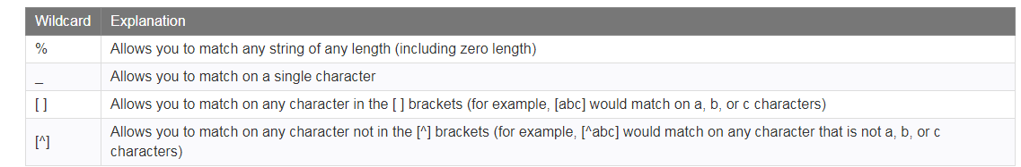

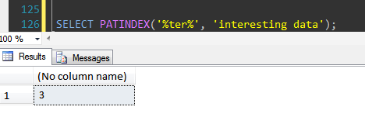

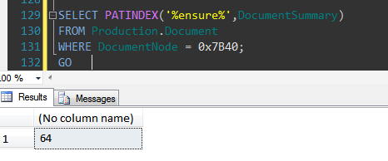

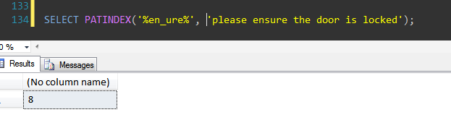

**Replace Function**

* Replace all occurrences of the second given string expression in the first string expression with a third expression.
* Not case-sensitive.
* Occurrences of string_to_replace will be replaced with replacement_string regardless of the case of string_to_replace or replacement_string.

**REPLACE (string1, string_to_replace, replacement_string )**

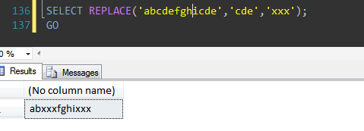

**Stuff Function**

* Used to replace characters in a string.
* Used to delete a certain length of the string and replace it with a new string.
* Deletes a sequence of characters from a source string and then inserts another sequence of characters into the source string, starting at a specified position.

**STUFF (source string, start, length, add string)**

